Supplement:

Joint modelling of liver transplant candidates outperforms the model for end-stage liver disease: the effect of disease development over time on patient outcome

B.F.J. Goudsmit MD,1,2,3 A.E. Braat MD PhD1,M.E. Tushuizen MD PhD3,4, S. Vogelaar MD2, J. Pirenne MD PhD5,6, I.P.J. Alwayn MD PhD,1,4 B. van Hoek MD PhD,3,4* H. Putter PhD7*

*)joint senior authors

Affiliations:

Division of Transplantation, Department of Surgery,1 Leiden University Medical Centre, The Netherlands.

Eurotransplant International Foundation,2 Leiden, The Netherlands

Department of Gastroenterology and Hepatology,3 Leiden University Medical Centre, The Netherlands.

Transplant Center,4 Leiden University Medical Centre, The Netherlands.

Department of Abdominal Transplant Surgery,5 University Hospitals Leuven, Leuven, Belgium.

Representative of the Eurotransplant Liver Intestine Advisory Committee6.

Department of Biomedical Data Sciences,7 Leiden University Medical Centre, The

Netherlands.

Contents

Instruction manual MELD(Na)-JM applications 3

Table S1: AUCs for the MELD-JM and MELD in Eurotransplant 4

Table S2: Brier scores (prediction errors) for the MELDNa-JM and MELD-Na 5

Table S3: Brier scores (prediction errors) for the MELD-JM and MELD 6

Table S4: analysis of prior (2007-2012) and recent (2013-2018) Eurotransplant cohorts. 7

Table S5: sensitivity analysis: exclusion of HCV patients 8

Table S6: characteristics of MELD and MELD-JM differently-prioritized patients 9

Table S7: 90-day mortality AUCs of the LT-JM (based on more predictors) versus MELD-Na 10

Figure S1: ROC plot MELD-JM versus MELD 11

Figure S2: calibration plot MELD-JM versus MELD 12

Figure S3: MELD trajectories of differently-prioritized patients. 13

Figure S4: last measurement carried-on-forward by time-dependent Cox models. 14

Figure S5: MELDNa-JM AUCs per candidate sex 15

Figure S6: MELDNa-JM AUCs per candidate etiology of disease 16

Figure S7: MELDNa-JM AUCs per candidate race/ethnicity 17

Missingness analysis 18

# Instruction manual MELD(Na)-JM applications

The joint models MELD-JM (<https://predictionmodels.shinyapps.io/meld-jm/>) and MELDNa-JM (<https://predictionmodels.shinyapps.io/meldna-jm/>) can be used to calculate predictions of waiting list survival for individual patients. Individual patient data must be uploaded in repeated measurement format. This means that for each new MELD(-Na) measurement, a new time of measurement and MELD(-Na) score is added.

Please format your patient data as follows:

* column 1: arbitrary patient ID, e.g. 1
* column 2: meldna
* column 3: time_of_measurement

Example data:

|  |  |  |
| --- | --- | --- |
| id | time_of_measurement | meldna |
| 1 | 0 | 27 |
| 1 | 5 | 24 |
| 1 | 6 | 24 |
| 1 | 11 | 26 |
| 1 | 13 | 26 |
| 1 | 14 | 27 |
| 1 | 21 | 25 |
| 1 | 24 | 25 |
| 1 | 31 | 25 |
| 1 | 34 | 28 |
| 1 | 35 | 29 |
| 1 | 36 | 30 |
| 1 | 37 | 32 |
| 1 | 38 | 33 |
| 1 | 39 | 32 |
| 1 | 40 | 33 |
| 1 | 42 | 34 |
| 1 | 43 | 35 |
| 1 | 45 | 40 |
| 1 | 48 | 40 |
| 1 | 49 | 40 |
| 1 | 50 | 40 |

The MELD-Na scores are measured repeatedly in the same patient. The time_of_measurement denotes the time in days since first measurement. For example, at day 0, the patient enters the liver transplantation waiting list. At day 50, the clinician would like to assess the survival probabilities calculated by the ACLF-JM. Data is prepared in three columns, the last measurement is the most recent one. time_of_measurement is thus counted from day 0 (start date of measurement or waiting list entry) until the last available date.

# Table S1: AUCs for the MELD-JM and MELD in Eurotransplant

|  |  |  |  |  |  |  |  |
| --- | --- | --- | --- | --- | --- | --- | --- |
| 90-day mortality AUCs of the MELD-JM versus the MELD,  at baseline and during waiting list follow-up | | | | | | | |
| Time (months) | **MELD-JM** | low95 | upp95 | **MELD** | low95 | upp95 | p |
| 0 | 0.94 | 0.92 | 0.95 | 0.87 | 0.85 | 0.89 | *** |
| 3 | 0.89 | 0.87 | 0.91 | 0.80 | 0.76 | 0.83 | *** |
| 6 | 0.88 | 0.86 | 0.91 | 0.82 | 0.78 | 0.86 | *** |
| 9 | 0.85 | 0.80 | 0.89 | 0.76 | 0.69 | 0.83 | *** |
| 12 | 0.84 | 0.80 | 0.89 | 0.78 | 0.71 | 0.85 | 0.01 |
| 15 | 0.84 | 0.77 | 0.90 | 0.80 | 0.73 | 0.87 | NS |
| 18 | 0.81 | 0.74 | 0.88 | 0.78 | 0.71 | 0.86 | NS |
| 21 | 0.81 | 0.73 | 0.88 | 0.81 | 0.73 | 0.89 | NS |
| 24 | 0.81 | 0.72 | 0.89 | 0.80 | 0.71 | 0.99 | NS |
| *** p<0.001, NS: not significant | | | | | | | |
| AUC: area under receiver operator curve | | | | | | | |
| JM: joint model, MELD: model for end-stage liver disease score | | | | | | | |

# Table S2: Brier scores (prediction errors) for the MELDNa-JM and MELD-Na

|  |  |  |  |  |  |  |  |
| --- | --- | --- | --- | --- | --- | --- | --- |
| 90-day mortality mortality prediction prediction errors of the MELDNa-JM versus the MELD-Na, at baseline and during waiting list follow-up | | | | | | | |
| Time (months) | **MELDNa-JM** | low95 | upp95 | **MELD-Na** | low95 | upp95 | p |
| 0 | 0.059 | 0.000 | 0.268 | 0.082 | 0.000 | 0.322 | *** |
| 3 | 0.056 | 0.032 | 0.081 | 0.065 | 0.052 | 0.076 | *** |
| 6 | 0.051 | 0.032 | 0.069 | 0.060 | 0.048 | 0.072 | *** |
| 9 | 0.051 | 0.034 | 0.068 | 0.056 | 0.041 | 0.071 | *** |
| 12 | 0.046 | 0.030 | 0.062 | 0.048 | 0.033 | 0.067 | *** |
| 15 | 0.046 | 0.029 | 0.063 | 0.047 | 0.030 | 0.065 | *** |
| 18 | 0.056 | 0.034 | 0.079 | 0.059 | 0.030 | 0.083 | *** |
| 21 | 0.048 | 0.025 | 0.071 | 0.051 | 0.022 | 0.081 | *** |
| 24 | 0.054 | 0.024 | 0.084 | 0.057 | 0.027 | 0.092 | *** |
| *** p<0.001 | | | | | | | |
| JM: joint model, MELD-Na: model for end-stage liver disease sodium score | | | | | | | |

# Table S3: Brier scores (prediction errors) for the MELD-JM and MELD

|  |  |  |  |  |  |  |  |
| --- | --- | --- | --- | --- | --- | --- | --- |
| 90-day mortality prediction errors of the joint models versus the MELD, at baseline and during waiting list follow-up | | | | | | | |
| Time (months) | **MELD-JM** | low95 | upp95 | **MELD** | low95 | upp95 | p |
| 0 | 0.050 | 0.045 | 0.056 | 0.065 | 0.058 | 0.071 | *** |
| 3 | 0.043 | 0.036 | 0.050 | 0.054 | 0.049 | 0.060 | *** |
| 6 | 0.044 | 0.036 | 0.052 | 0.054 | 0.048 | 0.060 | *** |
| 9 | 0.027 | 0.020 | 0.034 | 0.049 | 0.044 | 0.055 | *** |
| 12 | 0.031 | 0.023 | 0.040 | 0.056 | 0.051 | 0.062 | *** |
| 15 | 0.027 | 0.018 | 0.035 | 0.058 | 0.052 | 0.064 | *** |
| 18 | 0.020 | 0.012 | 0.028 | 0.060 | 0.054 | 0.066 | *** |
| 21 | 0.024 | 0.015 | 0.034 | 0.065 | 0.059 | 0.072 | *** |
| 24 | 0.027 | 0.016 | 0.038 | 0.061 | 0.055 | 0.067 | *** |
| *** p<0.001 | | | | | | | |
| JM: joint model, MELD: model for end-stage liver disease score | | | | | | | |

# Table S4: analysis of prior (2007-2012) and recent (2013-2018) Eurotransplant cohorts.

|  |  |  |  |  |  |  |  |
| --- | --- | --- | --- | --- | --- | --- | --- |
| 90-day mortality AUCs of the MELD-JM versus the MELD, at baseline and during waiting list follow-up | | | | | | | |
| Time (months) | **MELD-JM** | low95 | upp95 | **MELD** | low95 | upp95 | p |
| 0 | 0.93 | 0.91 | 0.95 | 0.84 | 0.81 | 0.87 | *** |
| 3 | 0.91 | 0.88 | 0.93 | 0.81 | 0.77 | 0.85 | *** |
| 6 | 0.89 | 0.86 | 0.93 | 0.81 | 0.75 | 0.87 | *** |
| 9 | 0.87 | 0.81 | 0.92 | 0.80 | 0.71 | 0.88 | 0.010 |
| 12 | 0.86 | 0.81 | 0.90 | 0.78 | 0.68 | 0.87 | 0.032 |
| 15 | 0.85 | 0.79 | 0.92 | 0.80 | 0.72 | 0.87 | 0.032 |
| 18 | 0.82 | 0.74 | 0.90 | 0.81 | 0.76 | 0.87 | NS |
| 21 | 0.83 | 0.75 | 0.92 | 0.80 | 0.69 | 0.90 | NS |
| 24 | 0.84 | 0.70 | 0.98 | 0.85 | 0.65 | 1.00 | NS |
| *** p<0.001 | | | | | | | |
| AUC: area under receiver operator curve | | | | | | | |
| JM: joint model, MELD: model for end-stage liver disease score | | | | | | | |

|  |  |  |  |  |  |  |  |
| --- | --- | --- | --- | --- | --- | --- | --- |
| 90-day mortality AUCs of the MELD-JM versus the MELD, at baseline and during waiting list follow-up | | | | | | | |
| Time (months) | **MELD-JM** | low95 | upp95 | **MELD** | low95 | upp95 | p |
| 0 | 0.95 | 0.93 | 0.97 | 0.90 | 0.87 | 0.93 | *** |
| 3 | 0.86 | 0.82 | 0.91 | 0.78 | 0.72 | 0.84 | *** |
| 6 | 0.87 | 0.83 | 0.92 | 0.83 | 0.78 | 0.88 | 0.006 |
| 9 | 0.81 | 0.74 | 0.89 | 0.70 | 0.60 | 0.81 | 0.011 |
| 12 | 0.82 | 0.73 | 0.91 | 0.78 | 0.67 | 0.89 | NS |
| 15 | 0.78 | 0.60 | 0.96 | 0.81 | 0.64 | 0.98 | NS |
| 18 | 0.79 | 0.67 | 0.91 | 0.71 | 0.50 | 0.93 | NS |
| 21 | 0.74 | 0.60 | 0.88 | 0.84 | 0.76 | 0.93 | NS |
| 24 | 0.73 | 0.57 | 0.90 | 0.81 | 0.72 | 0.90 | NS |
| *** p<0.001 | | | | | | | |
| AUC: area under receiver operator curve | | | | | | | |
| JM: joint model, MELD: model for end-stage liver disease score | | | | | | | |

# Table S5: sensitivity analysis: exclusion of HCV patients

|  |  |  |  |  |  |  |  |
| --- | --- | --- | --- | --- | --- | --- | --- |
| HCV excluded: 90-day mortality AUCs of the MELD-JM versus the MELD, at baseline and during waiting list follow-up | | | | | | | |
| Time (months) | **MELD-JM** | low95 | upp95 | **MELD** | low95 | upp95 | p |
| 0 | 0.94 | 0.93 | 0.95 | 0.86 | 0.84 | 0.89 | *** |
| 3 | 0.89 | 0.87 | 0.92 | 0.81 | 0.77 | 0.84 | *** |
| 6 | 0.88 | 0.85 | 0.91 | 0.82 | 0.78 | 0.86 | *** |
| 9 | 0.84 | 0.79 | 0.89 | 0.74 | 0.67 | 0.81 | *** |
| 12 | 0.84 | 0.79 | 0.89 | 0.77 | 0.70 | 0.85 | 0.010 |
| 15 | 0.81 | 0.73 | 0.89 | 0.77 | 0.69 | 0.85 | NS |
| 18 | 0.81 | 0.73 | 0.89 | 0.77 | 0.68 | 0.87 | NS |
| 21 | 0.83 | 0.75 | 0.91 | 0.81 | 0.72 | 0.90 | NS |
| 24 | 0.88 | 0.78 | 0.99 | 0.86 | 0.73 | 0.99 | NS |
| *** p<0.001 | | | | | | | |
| AUC: area under receiver operator curve | | | | | | | |
| JM: joint model, MELD: model for end-stage liver disease score | | | | | | | |

# Table S6: characteristics of MELD and MELD-JM differently-prioritized patients

|  |  |  |  |  |  |
| --- | --- | --- | --- | --- | --- |
| Characteristics of differently-prioritized patients | | | | | |
|  | Both | MELD-JM prioritized | MELD prioritized | Not prioritized | p† |
| n | 1,177 | 268 | 268 | 3,619 |  |
| Age (median [IQR]) | 56.0 [49.0, 61.0] | 56.5 [48.8, 63.0] | 55.0 [49.0, 61.0] | 55.0 [48.0, 61.0] | NS |
| Female sex (%) | 403 (34.2) | 97 (36.2) | 89 (33.2) | 1176 (32.5) | NS |
| Death within 90 days (%) | 299 (25.4) | 62 (23.2) | 12 (4.6) | 86 (2.4) | <0.001 |
| Disease (%) |  |  |  |  | NS |
| Cirrhosis, HCV | 97 (8.2) | 24 (9.0) | 17 (6.3) | 456 (12.6) |  |
| Cirrhosis, alcohol induced | 535 (45.5) | 114 (42.5) | 123 (45.9) | 1307 (36.1) |  |
| Cirrhosis, other | 320 (27.2) | 72 (26.9) | 66 (24.6) | 786 (21.7) |  |
| Cholestatic | 115 (9.8) | 25 (9.3) | 17 (6.3) | 434 (12.0) |  |
| Metabolic | 45 (3.8) | 12 (4.5) | 11 (4.1) | 135 (3.7) |  |
| Benign | 11 (0.9) | 9 (3.4) | 18 (6.7) | 98 (2.7) |  |
| Other liver diseases | 54 (4.6) | 12 (4.5) | 16 (6.0) | 403 (11.2) |  |
| MELD score (median [IQR]) | 26.0 [23.0, 32.0] | 17.0 [15.0, 19.0] | 22.0 [21.0, 23.0] | 13.0 [10.0, 16.0] | <0.001 |
| † difference between MELD-JM and MELD prioritized patients | | | | | |

# Table S7: 90-day mortality AUCs of the LT-JM (based on more predictors) versus MELD-Na

|  |  |  |  |  |  |  |
| --- | --- | --- | --- | --- | --- | --- |
| 90-day mortality AUCs of the joint models versus the MELD-Na, at baseline and during waiting list follow-up | | | | | | |
| Time (months) | **LT-JM** | low95 | upp95 | **MELD-Na** | low95 | upp95 |
| 0 | 0.92 | 0.90 | 0.93 | 0.84 | 0.81 | 0.87 |
| 3 | 0.80 | 0.76 | 0.84 | 0.67 | 0.63 | 0.71 |
| 6 | 0.80 | 0.76 | 0.84 | 0.69 | 0.63 | 0.74 |
| 9 | 0.81 | 0.75 | 0.86 | 0.75 | 0.69 | 0.81 |
| 12 | 0.76 | 0.68 | 0.83 | 0.69 | 0.61 | 0.77 |
| 15 | 0.80 | 0.72 | 0.88 | 0.70 | 0.59 | 0.80 |
| 18 | 0.77 | 0.68 | 0.86 | 0.75 | 0.66 | 0.84 |
| 21 | 0.90 | 0.81 | 0.99 | 0.81 | 0.70 | 0.92 |
| 24 | 0.71 | 0.57 | 0.85 | 0.68 | 0.54 | 0.81 |
| *** p<0.001 | | | | | | |
| AUC: area under receiver operator curve | | | | | | |
| JM: joint model, MELD-Na: model for end-stage liver disease sodium score | | | | | | |

# Figure S1: ROC plot MELD-JM versus MELD

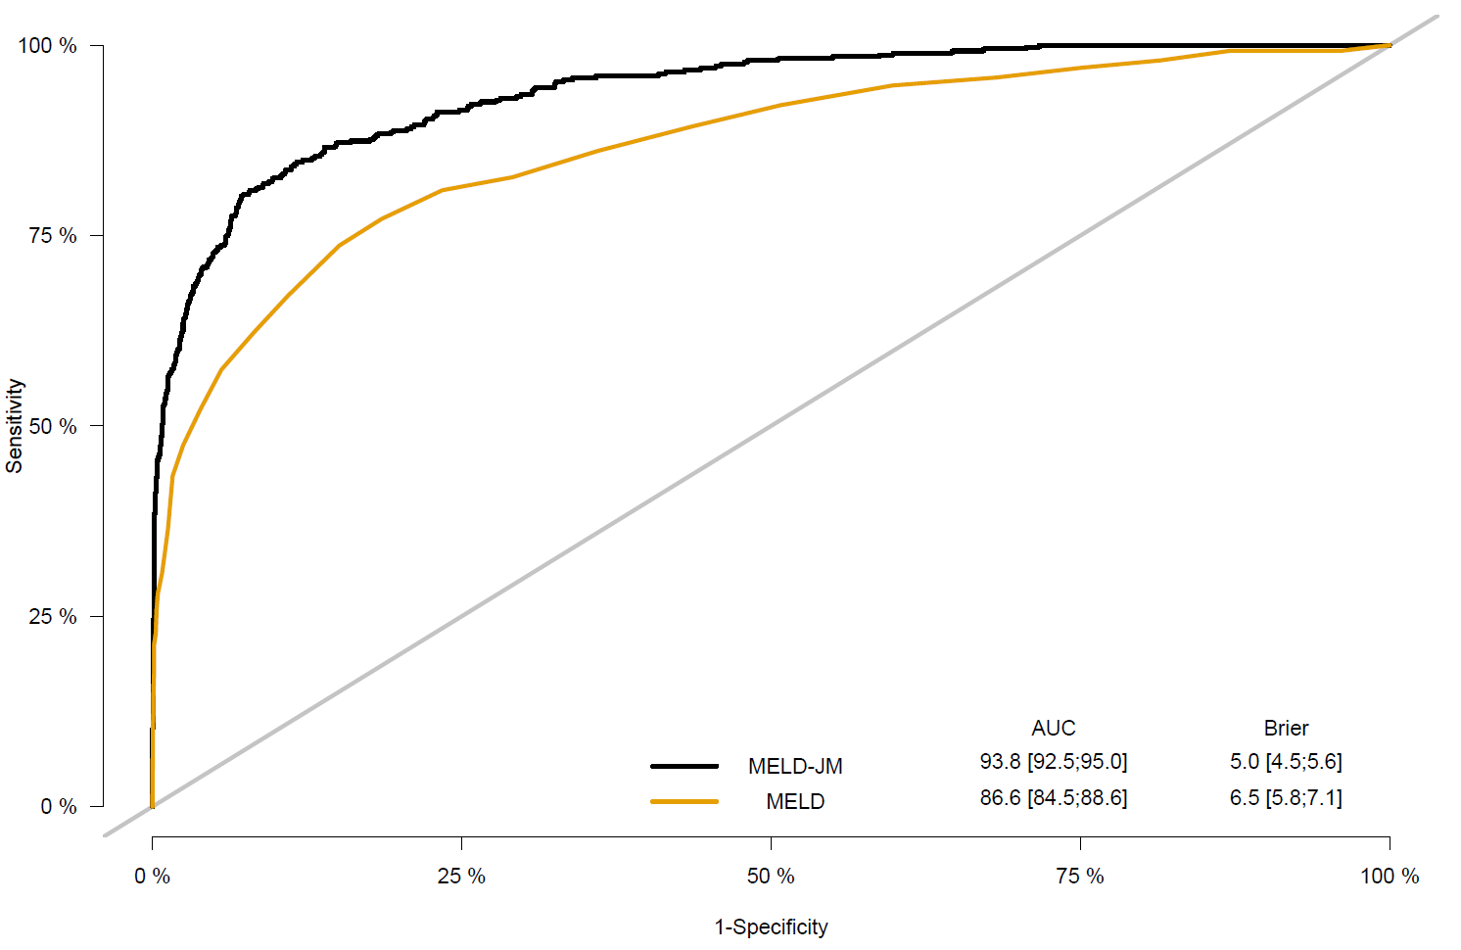

# Figure S2: calibration plot MELD-JM versus MELD

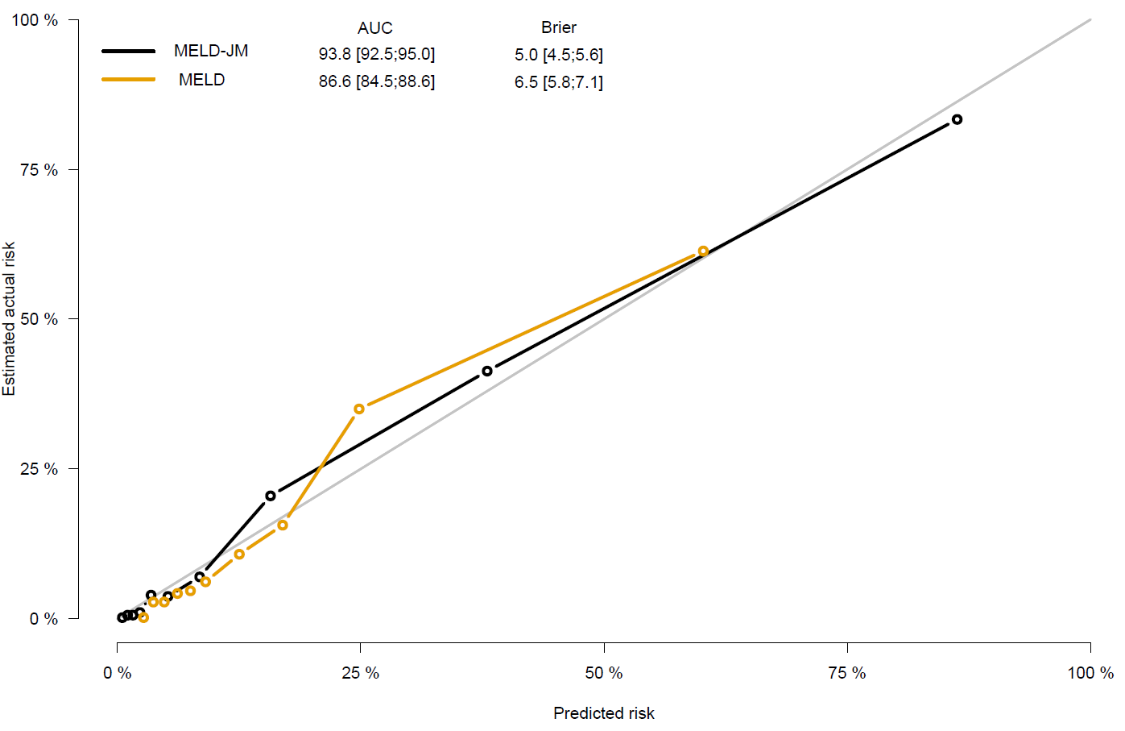

# Figure S3: MELD trajectories of differently-prioritized patients.

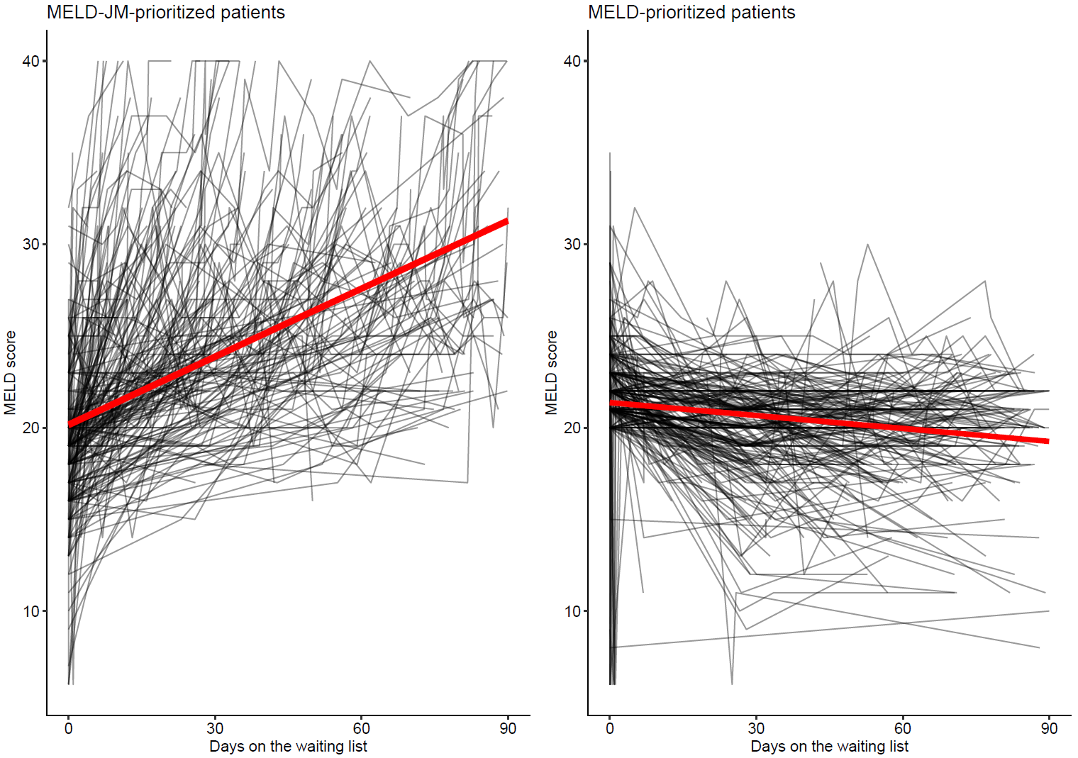

# Figure S4: last measurement carried-on-forward by time-dependent Cox models.

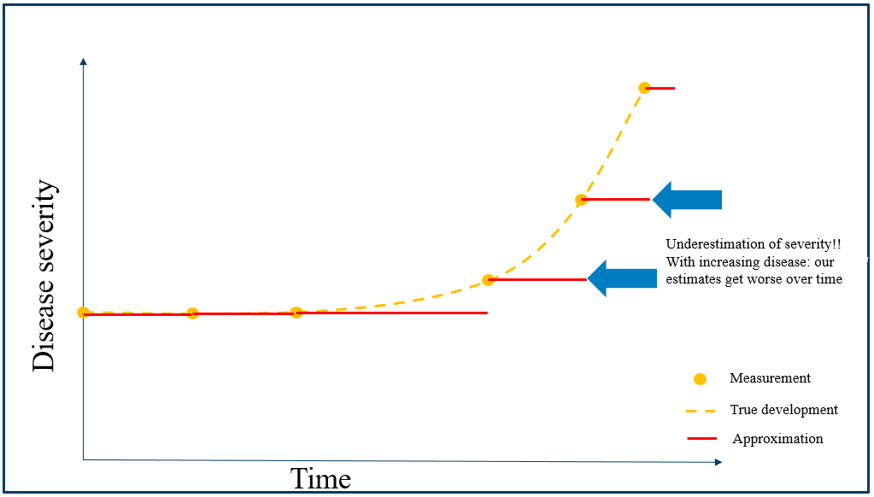

The time-dependent (TD) Cox model can give a inadequate representation of disease because of two reasons. First, it carries the last measurement on forward (red lines). With changing disease severity (here, increase is shown), the TD Cox gives an inadequate representation of disease. In this example, the TD Cox underestimates disease and therefore might give inappropriate LT priority. Second, the TD Cox linearly approximates development, whereas disease can develop non-linearly (e.g. hyperbolical).

# Figure S5: MELDNa-JM AUCs per candidate sex

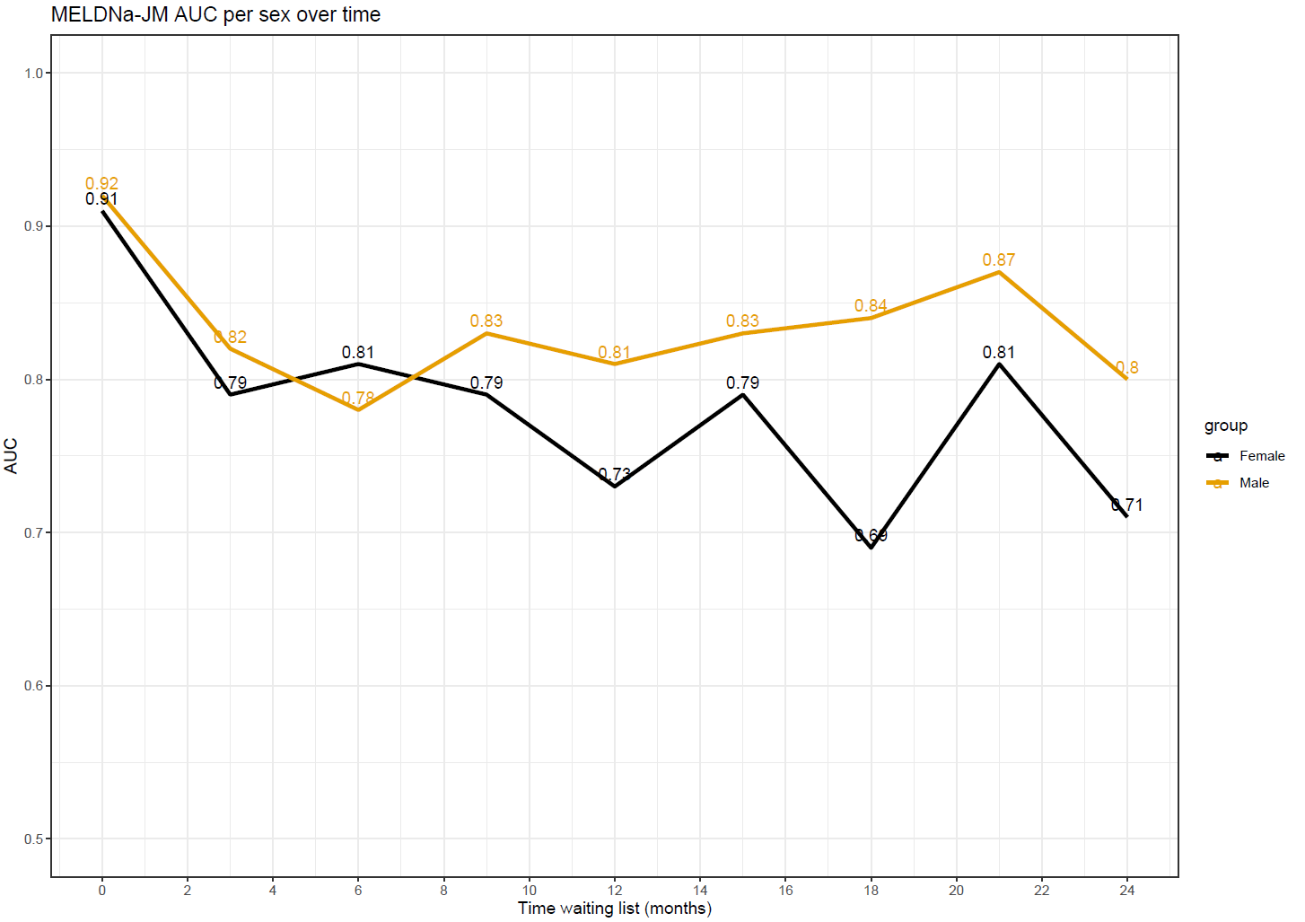

# Figure S6: MELDNa-JM AUCs per candidate etiology of disease

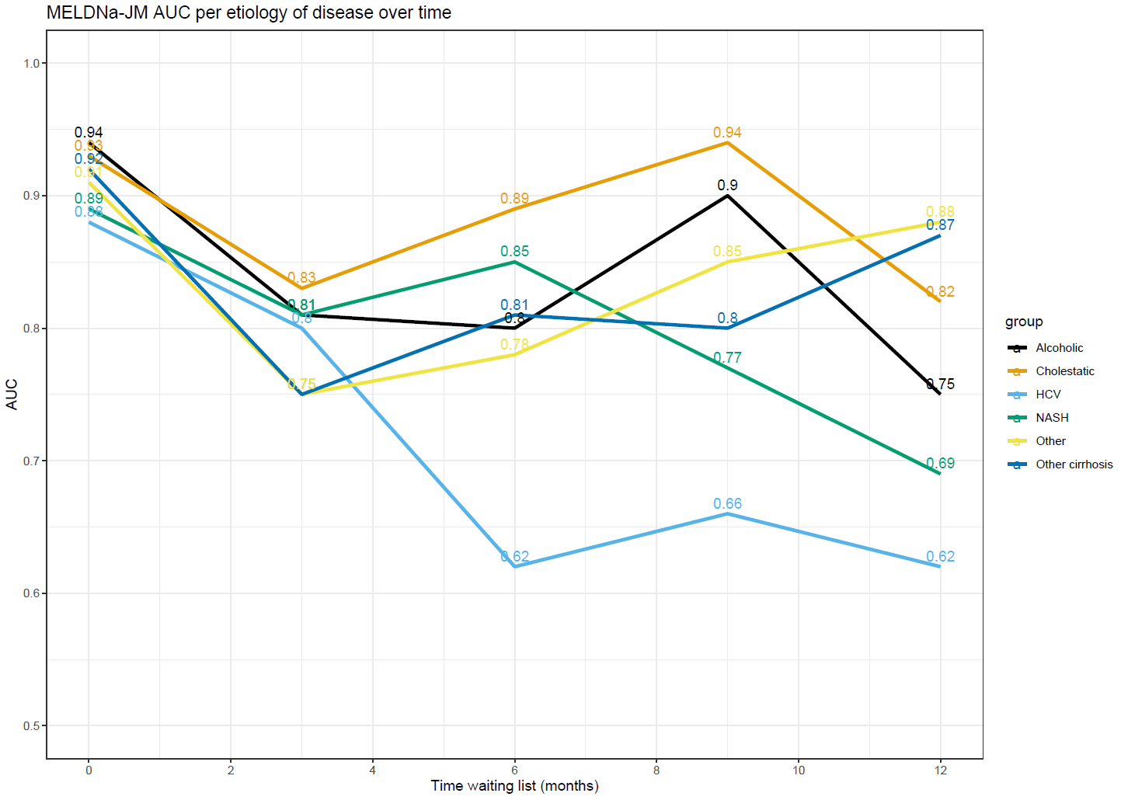

# Figure S7: MELDNa-JM AUCs per candidate race/ethnicity

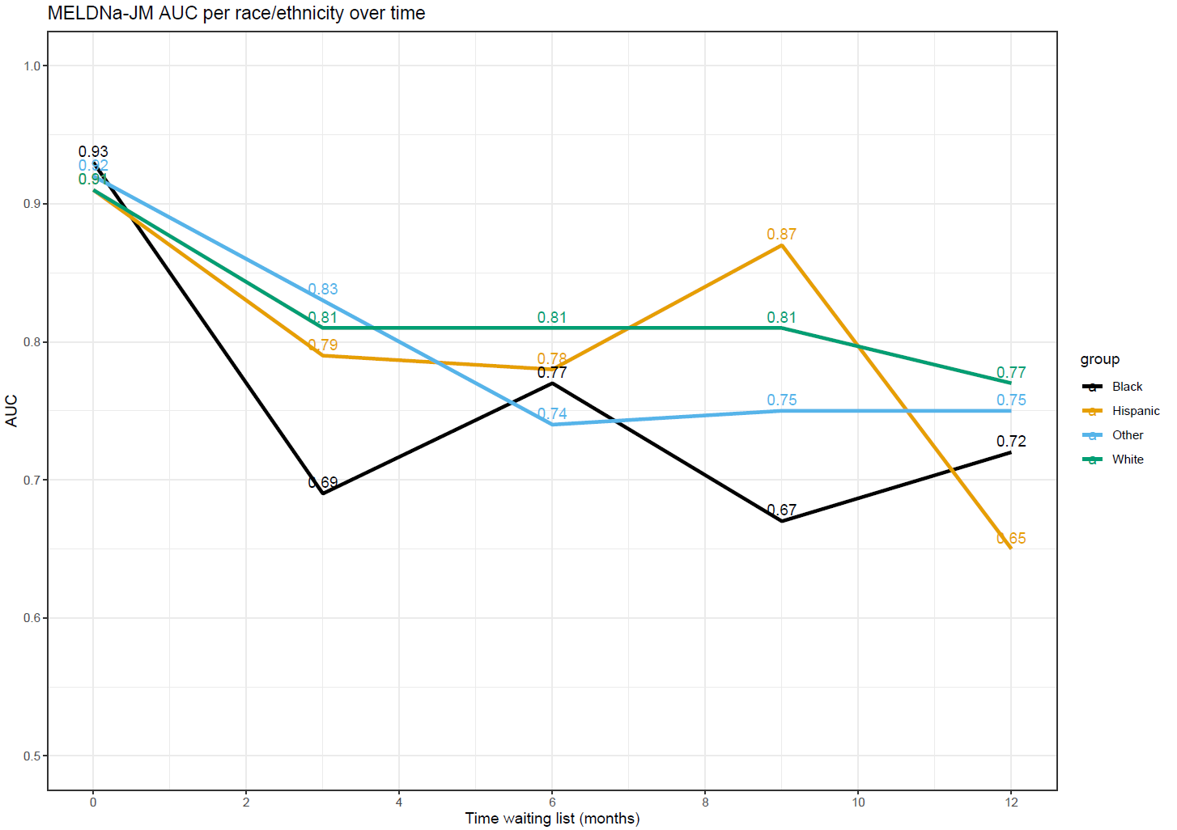

# Missingness analysis

Dependent missingness could lead to biased conclusions, most likely overestimation of waiting list mortality because lower MELD(-Na) scores would be missing. Still, the JMs can handle missingness better than Cox models, as JMs approximate ‘true’ disease development between measurements. Therefore, if the next updated MELD is lower, the trajectory between previous and last reported MELD will also be lower, which is then used in survival prediction. The JM assumes that measurements are missing regardless of their value. However, although the JMs are better suited to handle missingness, they still rely on the data at hand, like any method of analysis.

Statistical methods, like the joint model and Cox model, assume missing at random (MAR) data. For the waiting list, this means that MELD(-Na) missingness should not depend on unobserved values, but it may depend on observed values. Because unobserved values cannot be observed, MAR cannot be proven in this study or any other Eurotransplant/UNOS registry analysis. We did however assess the relation between MELD(-Na) value and reporting frequency.

Both in the Eurotransplant and UNOS regions, the frequency of required MELD updates depends on the MELD value, see the table below.

|  |  |  |
| --- | --- | --- |
| score | Eurotransplant:  MELD expires after | UNOS:  MELD-Na expires after |
| ≥25 | 2 days | 7 days |
| ≤24 , >18 | 7 days | 30 days |
| ≤18 , >10 | 90 days | 90 days |
| ≤10 | 365 days | 365 days |

*Adapted from:* [*https://optn.transplant.hrsa.gov/media/1200/optn_policies.pdf*](https://optn.transplant.hrsa.gov/media/1200/optn_policies.pdf)

Using the expiry per MELD(-Na) group, we assessed in the data whether centers reported lower MELD(-Na) scores and within how many days after previous update.

We hypothesized that if centers upload lower MELD(-Na) data well within time, the likelihood of dependent missingness bias could be reduced.

For the UNOS, 92-100% of decreasing (i.e., previously higher) MELD-Na scores <=18 were reported before the deadline (expiry date MELD-Na). Updating was more often voluntarily done for decreasing than for increasing scores.

|  |  |  |  |  |
| --- | --- | --- | --- | --- |
| **MELD-Na** | **Previously higher and updated** | | **Previously lower and updated** | |
|  | **Not voluntary** | **Voluntary** | **Not voluntary** | **Voluntary** |
| <=10 | 0% | 100% | 2% | 98% |
| >10 and <=18 | 8% | 92% | 13% | 87% |
| >18 and <=24 | 6% | 94% | 17% | 83% |
| >24 | 39% | 61% | 22% | 78% |
| Total | 18% | 82% | 18% | 82% |

Beside the frequency of updating, the time of updating is of interest. The table below shows the mean time difference between current and previous reported MELD-Na, grouped per MELD-Na score. This shows that lower but voluntarily reported <=10 MELD-Na are reported after 70 days on average, whereas MELD-Na <=10 but higher scores are reported after 34 days. This is well within time before the 365 days expiry. For MELD-Na >10 and <=18, voluntary updates of lower values are done after 33 days, whereas higher scores are updated after 19 days. Thus, it does take longer to report lower MELD-Na scores, but they are still reported well before expiry at 90 days. Involuntary updates are done in only a small part of the data.

|  |  |  |  |  |
| --- | --- | --- | --- | --- |
|  | **Mean time between current and previous measurement (days)** | | | |
| **MELD-Na** | **Previously higher and updated** | | **Previously lower and updated** | |
|  | **Not voluntary** | **Voluntary** | **Not voluntary** | **Voluntary** |
| <=10 | 420 | 70 | 374 | 34 |
| >10 and <=18 | 104 | 33 | 108 | 19 |
| >18 and <=24 | 41 | 11 | 48 | 8 |
| >24 | 8 | 4 | 15 | 2 |

For these “previously higher and voluntary update” MELD-Na scores we plotted the time difference between measurements (in days) against the difference in MELD-Na points, per MELD-Na group.

This plot shows that lower MELD-Na scores for e.g. MELD-Na <=10 patients (blue dots) are mostly updated before 100 days, whereas they only need to be updated before/at 365 days. The trend is also seen for >10 and <=18 MELD-Na score patients. Thus, despite the fact that the most recent MELD-Na is lower than the previous one, centers still report them and often well in time.

For the Eurotransplant region, the numbers are:

|  |  |  |  |  |
| --- | --- | --- | --- | --- |
| **MELD** | **Previously higher and update** | | **Previously lower and update** | |
|  | **Not voluntary** | **Voluntary** | **Not voluntary** | **Voluntary** |
| <=10 | 4% | 96% | 5% | 95% |
| >10 and <=18 | 20% | 80% | 23% | 77% |
| >18 and <=24 | 84% | 16% | 83% | 17% |
| >24 | 94% | 6% | 79% | 21% |
| Total | 4% | 96% | 51% | 49% |

Thus, for the Eurotransplant region, lower MELD scores are voluntarily reported more often than for the UNOS regions.

And the time difference:

|  |  |  |  |  |
| --- | --- | --- | --- | --- |
|  | **Mean time between current and previous measurement (days)** | | | |
| **MELD-Na** | **Previously higher and update** | | **Previously lower and update** | |
|  | **Not voluntary** | **Voluntary** | **Not voluntary** | **Voluntary** |
| <=10 | 506 | 99 | 513 | 118 |
| >10 and <=18 | 126 | 47 | 158 | 48 |
| >18 and <=24 | 22 | 4 | 37 | 3 |
| >24 | 7 | 1 | 14 | 1 |

For the Eurotransplant data, update frequency was roughly equal between previously higher and lower scores, which would indicate that for Eurotransplant data is reported regardless of the height of the MELD score, i.e. missingness could be independent of MELD value.

To conclude the investigation of dependent missingness: statistical methods assume random missingness in data. It is not possible to verify whether data is random or not-random missing in the data itself. Instead, one must rely on prior knowledge and can only assume that MELD(-Na) is updated regardless its value. Drastically stated, every study considering MELD(-Na) based on Eurotransplant or UNOS data suffers from this limitation and would be invalid without this assumption. A possible solution could be to increase the obligatory frequency of measurement for lower MELD(-Na) scores. That being said, in our cohort, we believe that both lower and higher values are updated voluntarily, well within time.

[this page is intentionally left empty]